\\ 21SW093

\\Task with Output

[\\OUTPUT](file:///\\OUTPUT)

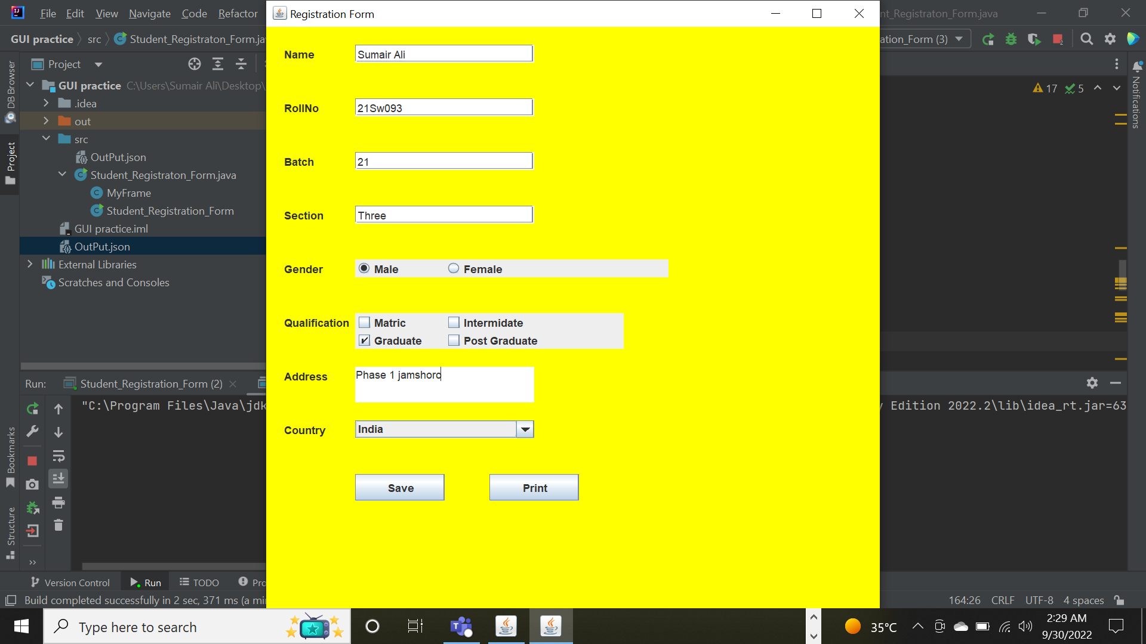

[\\NEW](file:///\\NEW) FRAME FOR PRINT

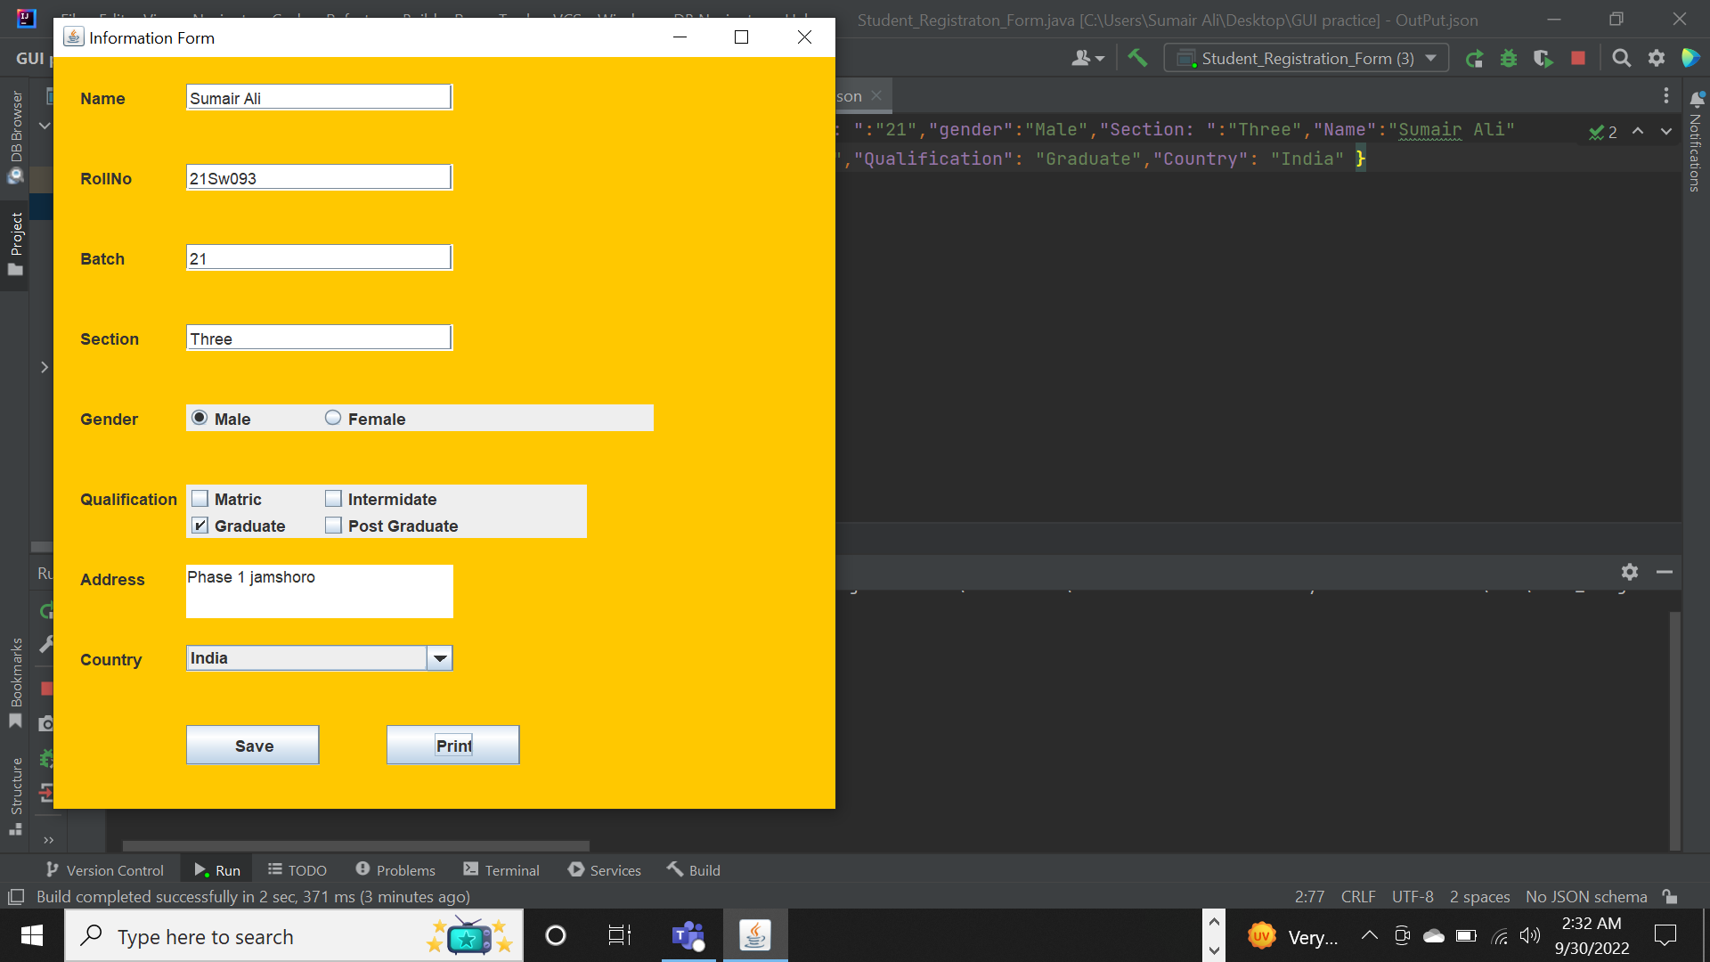

[\\OUTPUT](file:///\\OUTPUT) IN JSON FILE

